DBMS Practical – 2

1. Create the following tables and specify constraints at the time of creation.

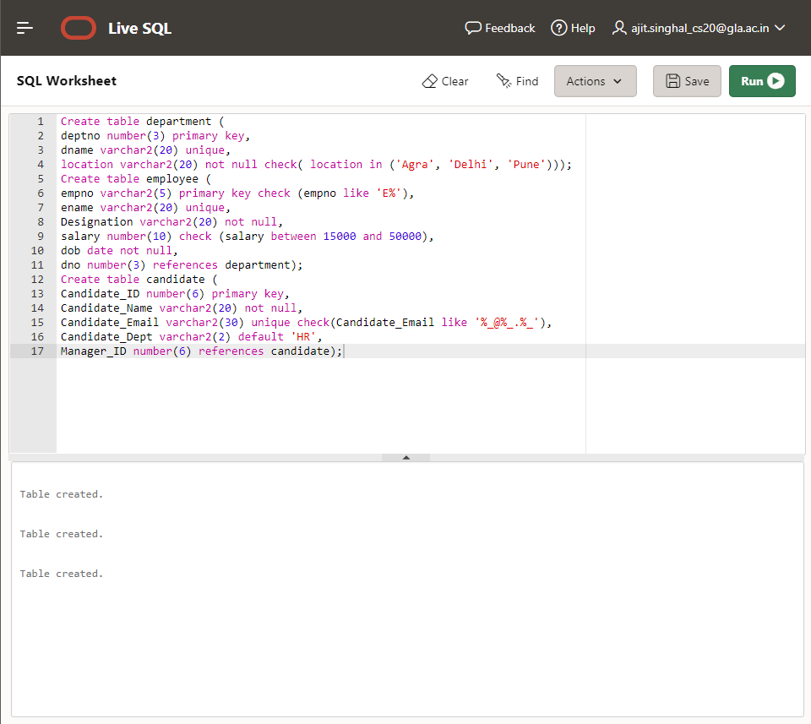

1. Add cName as Primary key in College.

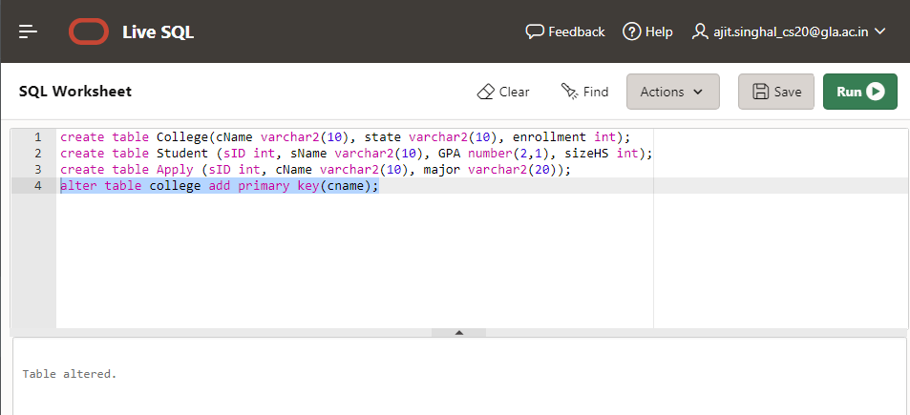

1. Add sID as Primarykey in Student.

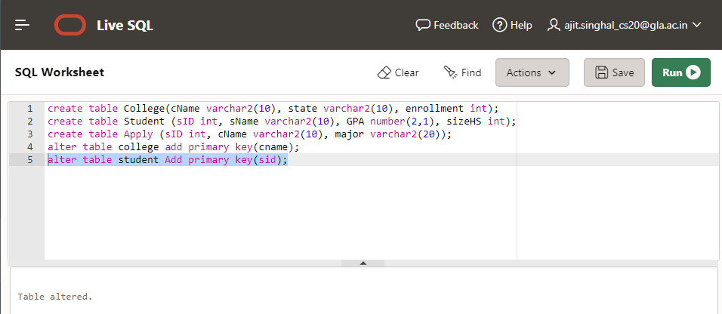

1. Add sID, cName, major as Primarykey in Apply.

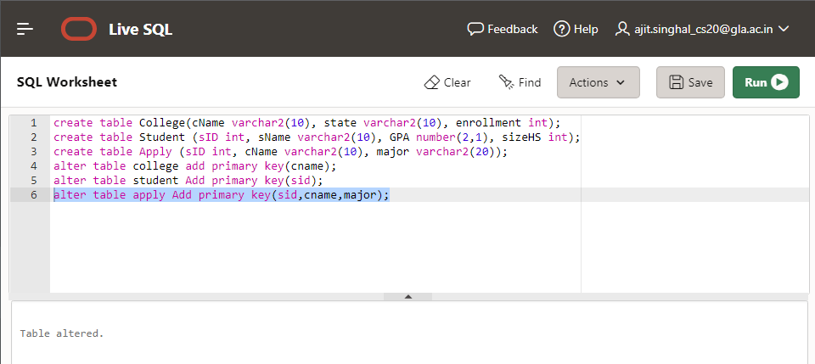

1. Make sID in Apply foreign key referring table student and cName referring table college.

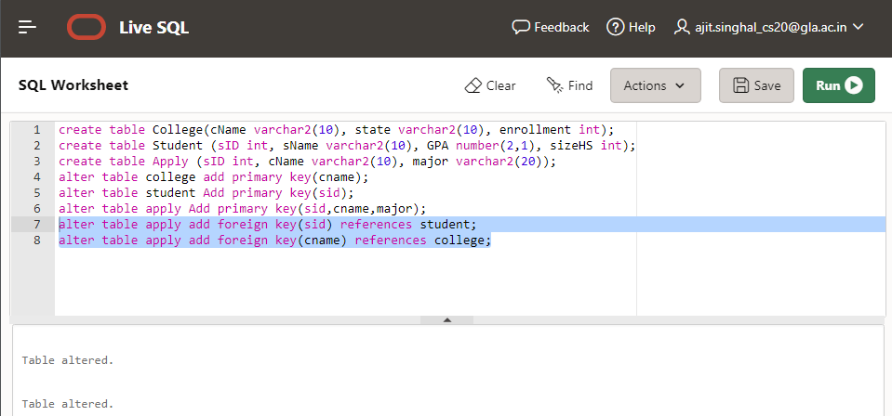

1. Increase data type size of major from 20 to 25.

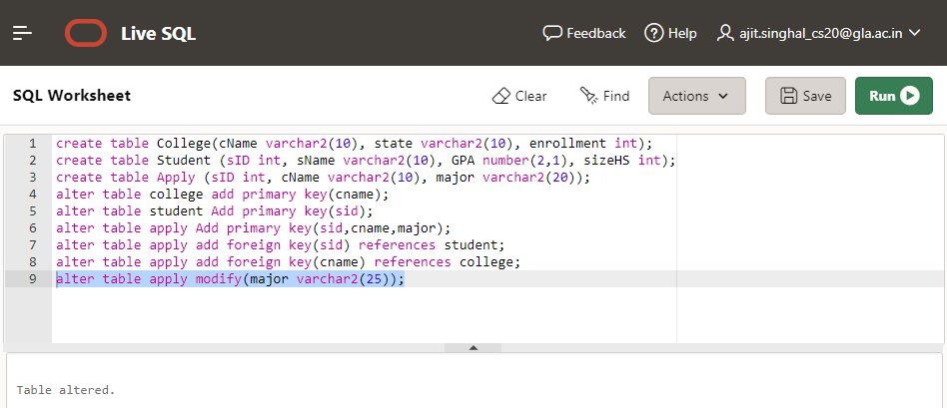

1. Add a new column decision in the Apply table keeping a constraint of not null for this column with data type varchar2(3).

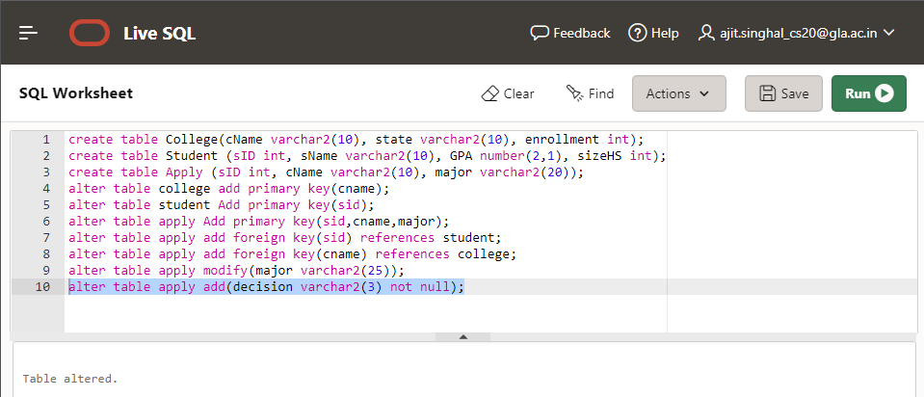

1. Change data type of decision in Apply to char(1).

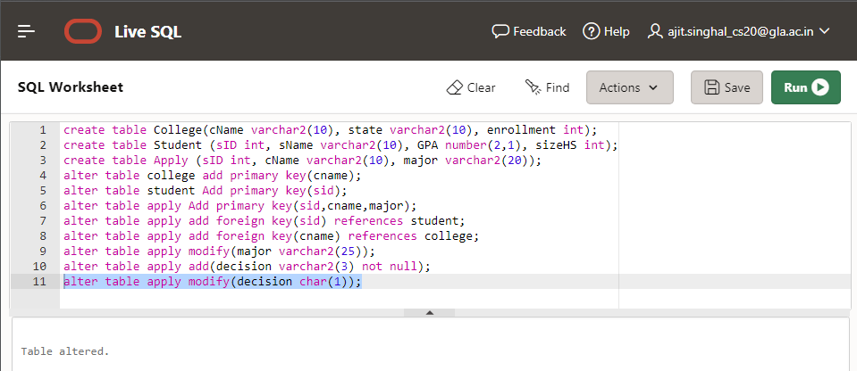

1. Drop foreign key on column name cName from Apply table.

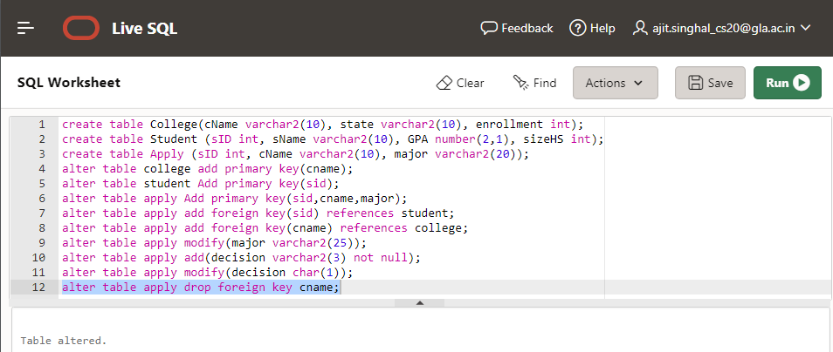

1. Remove column sizeHS from Student table.

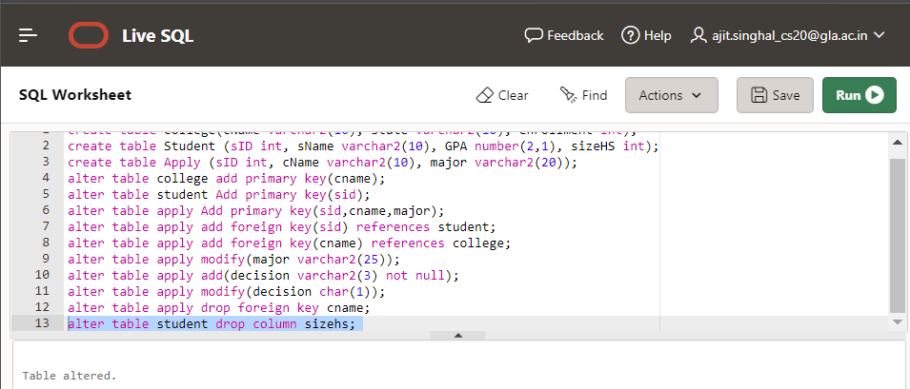

1. Drop primary key from College.

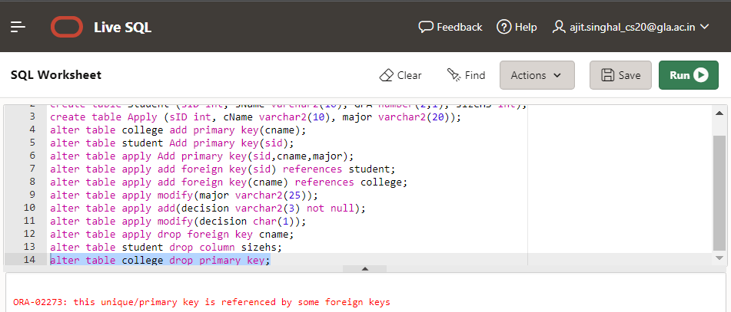

1. Make cName, majorunique pairwise such as Stanford CS, Stanford EE.

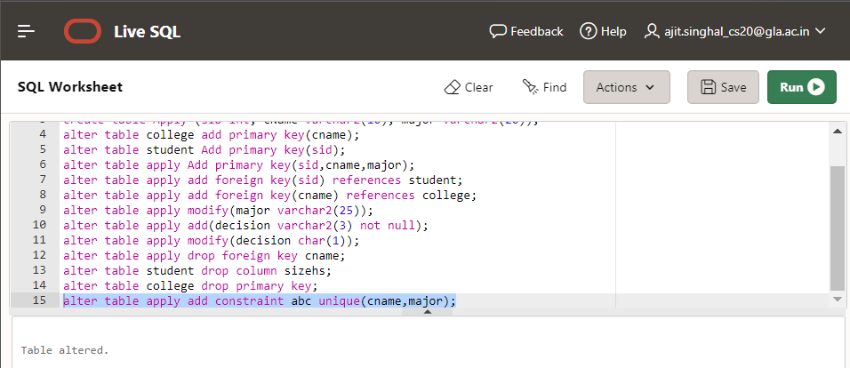

1. Add cName as Foreign Key in Apply table referring table College using on delete cascade.

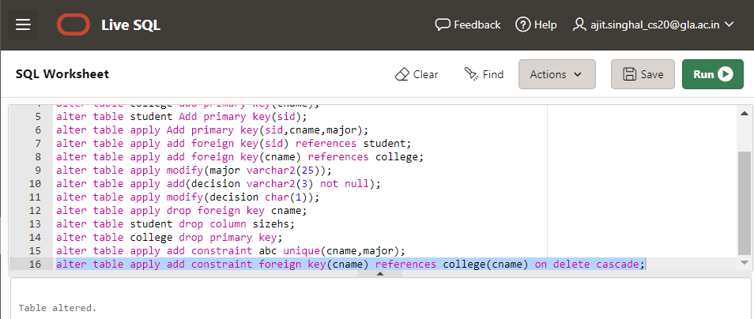

1. Modify foreign key on sID in Apply table to foreign key on delete set null.

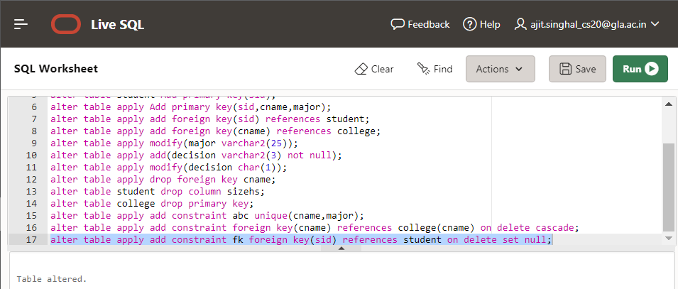

1. Rename column enrollment to enroll in College Table.

